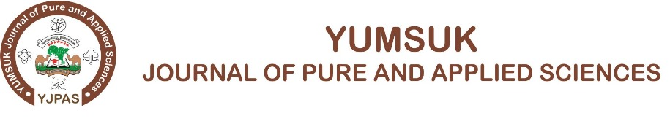
Research title: Times new roman 15
¹ Mani T., ² Mansur S.,
¹ Physics Department, Yusuf Maitama Sule University, Kano
² Physics Department, Gombe State University Gombe
* Corresponding Author e-mail: takai@yahoo.com

Abstract: Times new roman 12, not more than 250 words.

Keywords: Not more than five keywords

INTRODUCTION

Times new roman 12

MATERIALS AND METHOD

RESULT AND DISCUSSION

Figure 1:

Table 1:

CONCLUSION

REFERENCES

Cao, H., Wang, G., Zhang, S., Zhang, X., Rabinovich, D., & Carolina, N. (2006). Growth and Optical Properties of Wurtzite-Type CdS. Nanocrystals, 45(13), 5103–5108.

